FRICTION MODELLING OF A 6-DOF ROBOTIC ARM USING PHYSICS-BASED DATA-DRIVEN APPROACHES
Submitted By
Soumyadeep Dey
3rd-Year B.Tech Mechanical Engineering
National Institute of Technology Durgapur

ABSTRACT
Industrial robotic manipulators suffer from nonlinear friction effects arising from bearings, gearboxes, harmonic drives, seals, and transmission mechanisms. These friction effects reduce positioning accuracy, trajectory tracking performance, force control capability, and overall efficiency of robotic systems.
This work focuses on friction modelling of a 6-DOF Svaya robotic arm designed and developed by Savya Robotics. Experimental data consisting of motor torque, joint torque, position, and velocity were collected from the robot controller at a sampling frequency of 200 Hz. Classical friction models including Coulomb-Viscous and Stribeck models were investigated and compared with machine learning-based approaches.
The study demonstrates that classical friction models explain approximately 98% of the observed torque behaviour, while a neural network-based model achieves prediction accuracy exceeding 99%. Residual analysis reveals the presence of additional nonlinear dynamics which are not captured by conventional friction models.

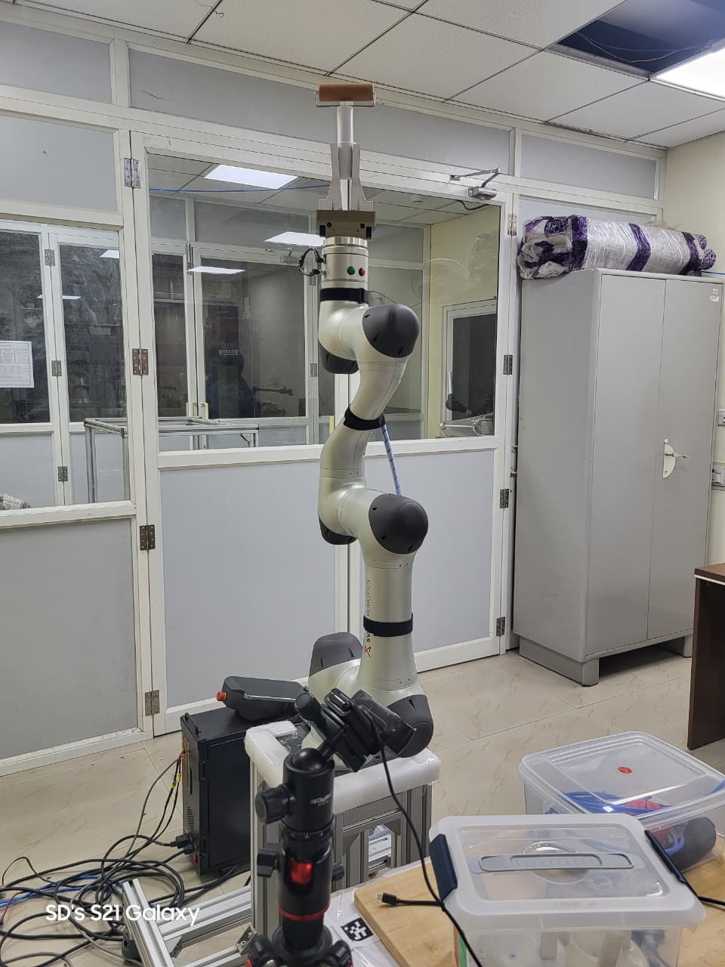

CHAPTER 1: INTRODUCTION

1.1 Background
Modern robotic manipulators are extensively used in manufacturing, aerospace, medical robotics, and collaborative industrial environments. The performance of these systems strongly depends on accurate modelling of joint dynamics. Industrial robotic manipulators rely on accurate torque transmission from motors to joints. However, due to friction and transmission losses, a portion of the motor-generated torque is lost before reaching the output joint.
These losses originate from bearing friction, gearbox friction, harmonic drive losses, lubrication effects, mechanical compliance, and manufacturing tolerances. Friction introduces tracking errors, positioning inaccuracies, stick-slip motion, limit cycles, energy losses, and reduced force control accuracy. For high-precision robotic applications, friction modelling and compensation becomes essential.

1.2 Motivation
Although modern robot controllers compensate for friction internally, significant residual friction remains due to gearbox nonlinearities, harmonic drive elasticity, bearing friction, lubrication effects, temperature variation, wear, and ageing. Accurate identification of these effects can improve motion accuracy, dynamic response, torque control, and energy efficiency. Therefore, friction modelling is an important step toward developing future friction compensation algorithms.

1.3 Objectives
The primary objectives of this project are:
- Study friction characteristics of a 6-DOF robotic arm.
- Estimate friction torque from experimental measurements.
- Investigate machine learning approaches for friction modelling.
- Compare physics-based and data-driven methods.
- Establish a pathway for future torque compensation.

CHAPTER 2: PROBLEM STATEMENT
The objective is to identify a mathematical relationship between the measured robot signals and the resulting friction-related torque losses. The available measurements for Joint-1 of a 6-DOF robotic manipulator are:
- Motor torque (Tm)
- Joint torque (Tj)
- Joint velocity (v)
- Joint position (q)
The gearbox ratio is N = 100. A residual torque quantity was defined as:
Tf = N × Tm − Tj
Tf = N × Tm − Tj is a residual torque quantity used as a surrogate measure of friction-related losses. It includes friction effects and may also contain contributions from unmodeled dynamics, gearbox compliance, measurement uncertainty, transmission losses, and control system effects. Therefore, it is treated as a friction-related residual rather than the true physical friction torque.

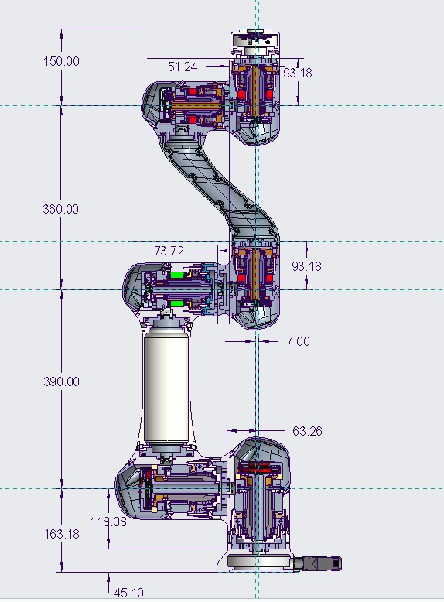

CHAPTER 3: ROBOT PLATFORM & KINEMATIC MODELLING

3.1 Robotic Arm
The experimental platform used in this work is a 6-DOF robot developed by Svaya Robotics. The robot is equipped with six revolute joints, harmonic drive transmission, joint position encoders, velocity estimation, joint torque sensing, and motor torque measurement.

3.2 Modified DH Parameters
Before performing friction modelling, it is important to understand how the robot geometry is mathematically represented using the Denavit-Hartenberg (DH) convention. The robot control framework contained the following Modified DH representation:
Joint | α (rad) | a (m) | d (m) | Offset
J1 | 0 | 0 | 0.16318 | 0
J2 | -π/2 | 0 | 0 | -π/2
J3 | 0 | 0.390 | -0.007 | π/2
J4 | π/2 | 0 | 0.360 | 0
J5 | -π/2 | 0 | 0 | 0
J6 | π/2 | 0 | 0 | 0
Tool | 0 | 0 | 0.150 | 0
[PLACEHOLDER: Insert DH Parameter Code Screenshot Here]

3.3 Forward Kinematics
Forward kinematics determines the end-effector position and orientation when all joint angles are known. Errors in torque transmission produce errors in joint motion, which propagate through the kinematic chain and affect the final end-effector position. Friction torque was observed to not solely depend on velocity but also showed dependence on joint configuration. This motivated the use of joint position (q) as an input feature in subsequent neural network models.

CHAPTER 4: LITERATURE REVIEW
Friction modelling has been an active research area in robotics, precision motion systems, and control engineering for several decades. The nonlinear nature of friction introduces tracking errors, stick-slip motion, limit cycles, energy losses, and degradation of control performance. Consequently, accurate friction modelling and compensation are essential for high-precision robotic manipulators.
The literature broadly classifies friction models into two categories:
- Static Friction Models
- Dynamic Friction Models
More recently, machine learning and Physics-Informed Neural Networks (PINNs) have emerged as alternative approaches for modelling complex friction phenomena.

4.1 Classical Friction Models
One of the most influential surveys on friction modelling was presented by Olsson et al. (1997), who reviewed the physical origins of friction and various friction models used in control applications. The authors highlighted that friction is caused by multiple physical mechanisms, including elastic deformation, plastic deformation, lubrication effects, contamination, and surface interactions. They emphasized that no single universal friction model exists because friction behaviour depends on operating conditions and material properties.
The study classified friction models into static and dynamic categories and showed that friction exhibits several nonlinear phenomena such as:
• Coulomb friction
• Static friction
• Stribeck effect
• Frictional lag
• Presliding displacement
• Hysteresis
The authors concluded that while simple models are computationally attractive, dynamic models are often required to capture the complete friction behaviour observed in real systems.

4.2 Coulomb and Viscous Friction Models
The simplest friction representation is the Coulomb friction model. In this model:
Ff = Fc sign(v)
where friction opposes motion with approximately constant magnitude. Although simple and computationally efficient, the Coulomb model cannot represent velocity-dependent effects and produces a discontinuity at zero velocity.
To overcome this limitation, viscous friction is added:
Ff = Fc sign(v) + Bv × v
where:
Fc = Coulomb friction coefficient
Bv = viscous coefficient
The viscous term captures lubrication and damping effects that increase with velocity.
According to van Geffen (2009), the Coulomb-Viscous model is often adequate for many industrial motion systems and forms the basis for numerous friction compensation strategies. However, it cannot accurately represent low-speed nonlinearities and friction hysteresis.

4.3 Stribeck Friction Model
Experimental studies have shown that friction often decreases as velocity increases from zero before eventually increasing due to viscous effects. This phenomenon is known as the Stribeck Effect. To model this behaviour, the Stribeck friction model introduces an exponential velocity-dependent term.
The Stribeck model captures:
• Breakaway friction
• Static friction
• Low-speed nonlinearities
• Lubrication effects
According to van Geffen (2009), the Stribeck model provides a significantly better representation of low-speed friction than the Coulomb-Viscous model and is widely used in robotic manipulators. However, the model remains a static friction model because friction is represented only as a function of velocity.

4.4 Dynamic Friction Models
Static friction models cannot represent hysteresis, friction memory, and presliding behaviour. To address these limitations, several dynamic friction models have been proposed. Among them, the Dahl model, LuGre model, Leuven model, and Generalized Maxwell Slip model are the most widely studied.
Dynamic models introduce internal state variables representing microscopic contact interactions between surfaces. These models can reproduce:
• Presliding displacement
• Frictional lag
• Hysteresis
• Memory effects
• Stick-slip motion
However, their increased complexity makes parameter identification significantly more challenging.

4.5 Machine Learning Based Friction Modelling
Traditional friction models rely on predefined mathematical equations. Although physically interpretable, they may not fully capture complex nonlinear relationships observed in robotic transmissions. Recent research has therefore explored machine learning approaches.
Neural networks learn friction behaviour directly from experimental data without requiring an explicit friction equation. Advantages include:
• Ability to model highly nonlinear behaviour
• Reduced dependence on physical assumptions
• Improved prediction accuracy
• Adaptability to different operating conditions
The main limitation is reduced physical interpretability and dependence on data quality.

4.6 Physics-Informed Neural Networks (PINNs)
Physics-Informed Neural Networks combine physical knowledge with machine learning. Instead of relying solely on experimental data, governing physical equations are incorporated into the neural network loss function. This provides:
• Improved generalization
• Reduced overfitting
• Better physical consistency
• Reduced data requirements
Recent studies have successfully applied PINNs to robotic friction modelling and parameter identification. Luo et al. (2024) proposed a PINN-based parameter identification framework for robotic manipulator friction models and demonstrated improved identification accuracy compared with Genetic Algorithms and Particle Swarm Optimization methods.
Similarly, Sorrentino et al. (2024) developed a PINN-based friction modelling framework for harmonic-drive robotic joints and reported improved friction compensation performance compared with traditional Coulomb-Viscous and Stribeck models. They have taken the load dynamics of a joint in account for estimating friction parameters of a humanoid robot.
These studies indicate that combining physical knowledge with neural networks offers a promising direction for future robotic friction modelling.

4.7 Research Gap
The literature reveals three important observations:
- Simple static friction models provide computational efficiency but cannot capture all nonlinear friction phenomena.
- Dynamic friction models improve physical realism but require difficult parameter identification and increased computational effort.
- Machine learning models achieve higher predictive accuracy but often lack physical interpretability.
- Currently most friction model researches are done either in MATLAB or online simulations which rejects the actual environment dynamics of the joint giving them an easy access to the dynamic modelling of friction parameters.
Most previous studies focus on either purely physics-based modelling or purely data-driven approaches. For the present work on Joint-1 of the robotic arm, the objective is first to evaluate the capability of classical friction models using experimentally measured robot data and then investigate whether machine learning methods can capture the remaining nonlinear behaviour observed in the residual torque signal. This provides the motivation for comparing classical friction models with neural-network-based friction modelling approaches.

CHAPTER 5: EXPERIMENTAL DATA ACQUISITION & PREPROCESSING

5.1 Data Collection
Experimental data were collected from Joint-1 of the robot using the Svaya Robotics API. Approximately 45,000 samples were recorded with a sampling frequency of 200 Hz (sampling interval Δt = 5 ms). A periodic forward-reverse trajectory was executed to excite positive and negative velocity regions, produce velocity reversals, and reveal friction hysteresis. Machine learning models require a sufficiently large number of samples to identify nonlinear relationships, reduce overfitting, and improve generalization.

5.2 Data Preprocessing
Joint position and velocity were originally recorded in degrees and degrees/s. These were converted into SI units (radians and radians/s) to ensure physically meaningful parameters, compatibility with future dynamic models, and consistency with published literature.

5.3 Training–Validation–Test Split
The dataset was divided sequentially: 60% Training Set, 20% Validation Set, and 20% Test Set. Because the data are time-series data, random shuffling was avoided to prevent data leakage from future information mixing into the training data. A chronological split more accurately represents real-world deployment.

CHAPTER 6: PHYSICS-BASED FRICTION MODELLING

6.1 Coulomb + Viscous Model
The first model investigated was the classical Coulomb-Viscous friction model. The model equation is: Tf(v) = Tc tanh(v/Vs) + Bv × v
Here, the tanh() function was used instead of sign() to avoid numerical optimization difficulties caused by discontinuities at zero velocity. This model was chosen first because it is physically interpretable, computationally efficient, and serves as a strong baseline.
Parameter identification (Tc, Bv, Vs) was performed using nonlinear least-squares curve fitting to minimize the squared error between actual and predicted torque.
Why this was chosen?
As discussed earlier in literature review, we would like to go step by step from static model to dynamic model for the ease of the project.

6.2 Stribeck Model
The Stribeck model captures low-speed nonlinear behaviour, including static friction, breakaway friction, and lubrication effects. The equation used is:
Tf(v) = [Tc + (Ts - Tc)e-(|v|/Vs)^α] tanh(v/ε) + Bv × v

6.3 Limitations of Physics-Based Models
Classical friction models struggle to represent gearbox elasticity, mechanical compliance, hysteresis, and transmission nonlinearities. If friction were the only phenomenon present, residual plots should resemble random noise. Instead, structured residuals and velocity reversal spikes indicate unmodelled nonlinear dynamics.

CHAPTER 7: DATA-DRIVEN FRICTION MODELLING

7.1 Black-Box Neural Network
Instead of enforcing physical assumptions, a purely data-driven Black-Box model was trained. The inputs were restricted to Position (q) and Velocity (v) to determine if friction behaviour can be learned directly from robot state variables. The architecture consisted of three dense layers (64, 64, 32 units) using ReLU activation and the Adam optimizer to minimize Mean Squared Error (MSE).

7.2 Model Evaluation Metrics
Models were evaluated using Root Mean Square Error (RMSE), Mean Absolute Error (MAE), and the R² Score, which measures the proportion of data variability explained by the model.
MAE –
R² score –

CHAPTER 8: RESULTS & COMPARATIVE ANALYSIS

8.1 Physics-Based Models Results
The Coulomb-Viscous model successfully captured the dominant friction characteristics, achieving an R² of 0.9799 (97.99% of variation explained).
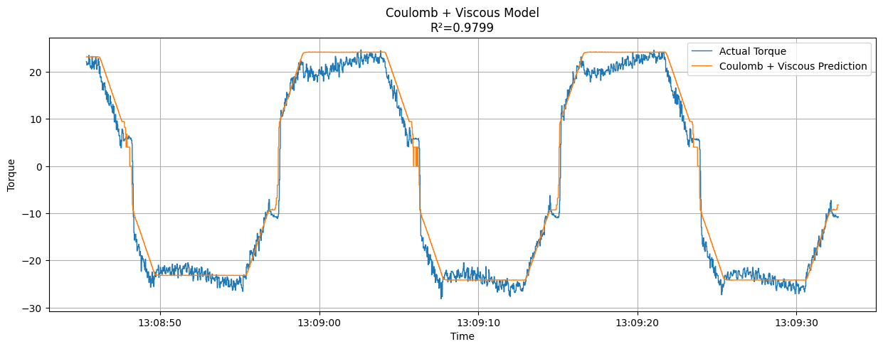
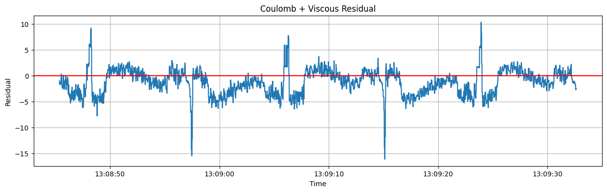
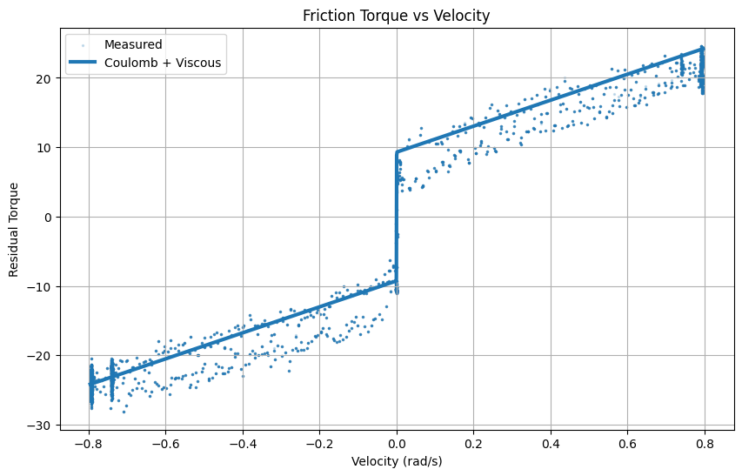
The Stribeck model produced nearly identical performance (R² ≈ 0.9799). The absence of significant improvement suggests the experimental data lack a strong Stribeck region, since Stribeck has a power term alpha which is becoming difficult for the curve fitting model to predict, making the Coulomb-Viscous model sufficient for basic physics representation.

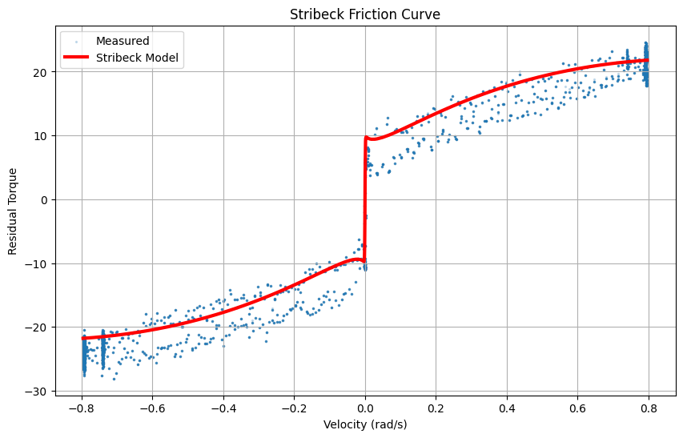

8.2 Black-Box Model Results
The pure neural network model achieved an R² of 0.9953, capturing 99.53% of the observed variation. This high performance occurs because the network is not restricted by predefined equations, allowing it to capture nonlinear relationships directly from data.
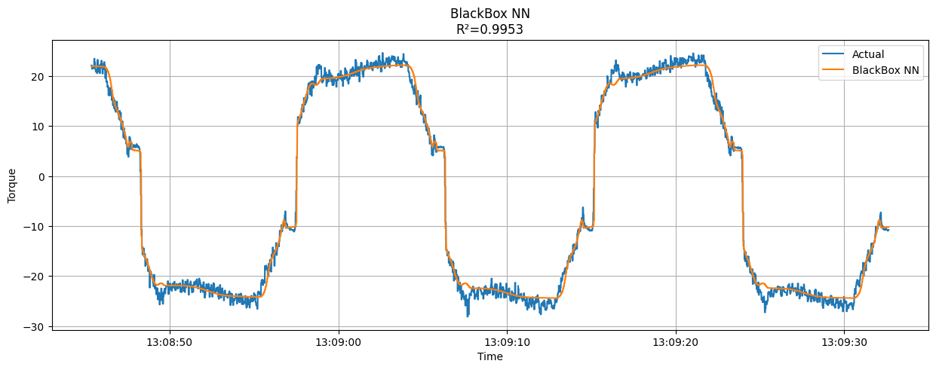
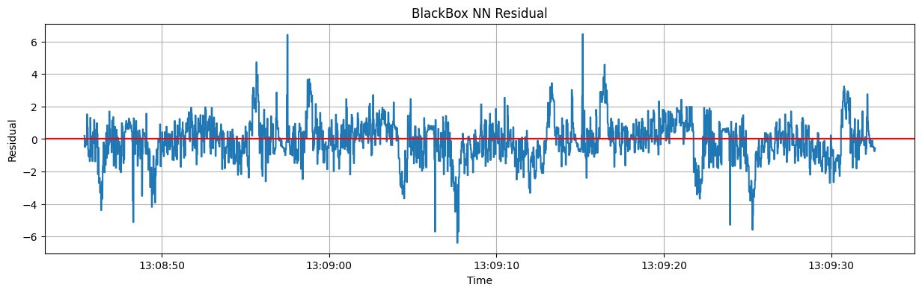

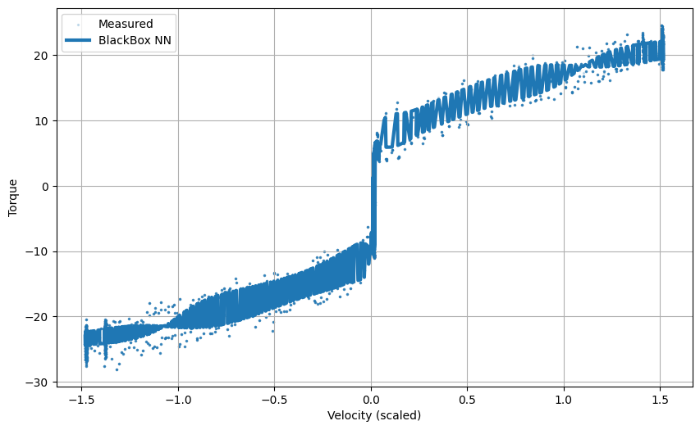

8.4 Comparative Summary
Model | R² Score
Coulomb + Viscous | 0.9799
Stribeck | 0.9799
BlackBox NN | 0.9953

CHAPTER 9: CONCLUSIONS
- Friction is the dominant source of torque loss in the Svaya robot.
- Coulomb-Viscous friction explains approximately 98% of the observed behaviour.
- Stribeck effects are weak under the tested operating conditions and offer no meaningful improvement.
- Residual analysis indicates the existence of additional nonlinear dynamics, specifically from spring mass and damper system likely originating from harmonic drive elasticity, compliance, and unmodelled transmission dynamics.
- The Black-Box neural network achieved the highest prediction accuracy (R² = 0.9953).
- Data-driven methods show strong potential for future torque compensation of the Svaya manipulator.

CHAPTER 10: FUTURE WORK
- Implementation of the LuGre dynamic friction model.
- Exploration of Physics-Informed Neural Networks (PINNs) to bridge the gap between grey-box and black-box limitations.
- Modelling multi-joint coupled dynamics.
- Online adaptive learning for real-time friction compensation deployed directly on the robot controller.

REFERENCES
[1] Armstrong-Hélouvry, B., Dupont, P., Canudas-De-Wit, C. 'A Survey of Models, Analysis Tools and Compensation Methods for the Control of Machines with Friction.'
[2] Canudas-De-Wit, C., Olsson, H., Astrom, K.J., Lischinsky, P. 'A New Model for Control of Systems with Friction.'
[3] Olsson, H., Åström, K. J., Canudas de Wit, C., Gäfvert, M., & Lischinsky, P. (1997). 'Friction Models and Friction Compensation.'
[4] van Geffen, V. (2009). 'A Study of Friction Models and Friction Compensation.'
[5] Rizos, D. D., & Fassois, S. D. (2005). 'Friction identification based upon the extended Maxwell slip model.'
[6] Luo, Y., et al. (2024). 'Research on Parameter Identification Method for Robotic Manipulators Joint Friction Model Based on PINN.'
[7] Sorrentino, S., et al. (2024). 'PINN-based friction modelling framework for harmonic-drive robotic joints.'
[8] Svaya Robotics User Manual, 2023.
[9] Khalil, W., Dombre, E. Modeling, Identification and Control of Robots.

